***Nicolas Campos de Carvalho***

***01192063***

***Avaliação Continuada 02 – Banco de Dados***

***Modelo Conceitual (brModelo)***

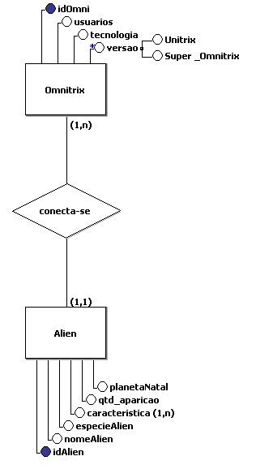

**-------------------------------------------------------------------------------------------------------------------**

***Modelo Lógico (MySQL Workbench)***

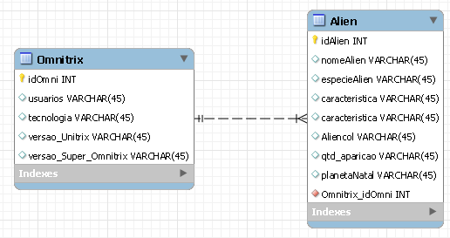

**-------------------------------------------------------------------------------------------------------------------**

***Script MySQL Workbench***

*create table ac02Nicolas;*

*use ac02Nicolas;*

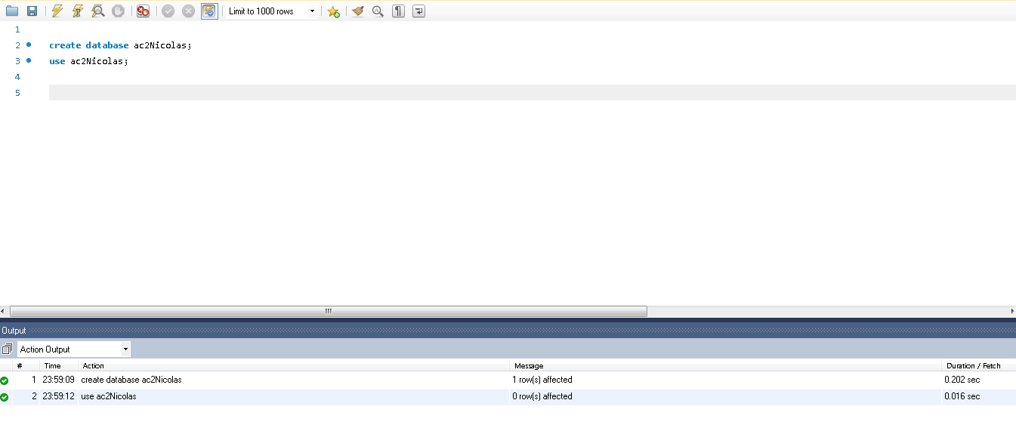

**-------------------------------------------------------------------------------------------------------------------**

*create table Omnitrix (*

*idOmni int primary key auto_increment,*

*usuarios varchar (20),*

*tecnologia varchar (20),*

*versao_Unitrix varchar (50),*

*versao_Super_Omnitrix varchar (50)*

*);*

*select * from Omnitrix;*

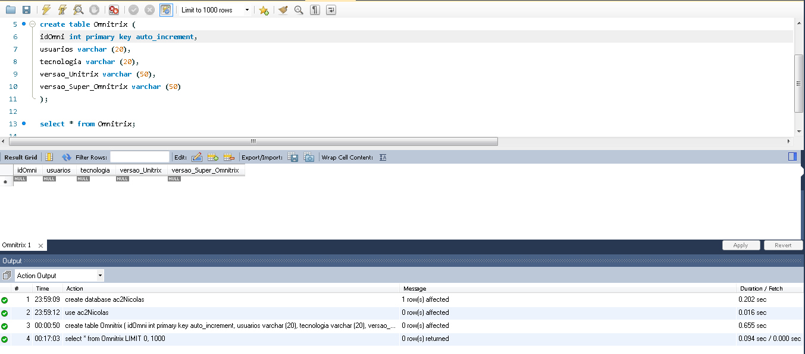

**-------------------------------------------------------------------------------------------------------------------**

*insert into Omnitrix (usuarios, tecnologia, versao_Unitrix, versao_Super_Omnitrix) values*

*('Maxwell Tennyson', 'Azimuth', 'Nemetrix', 'Primaria'),*

*('Benjamin Tennyson', 'Azimuth', 'Nemetrix', 'NEO Super Omnitrix'),*

*('Albedo', 'Cópia de Azimuth', 'Ultratrix','Super Omnitrix');*

*select * from Omnitrix;*

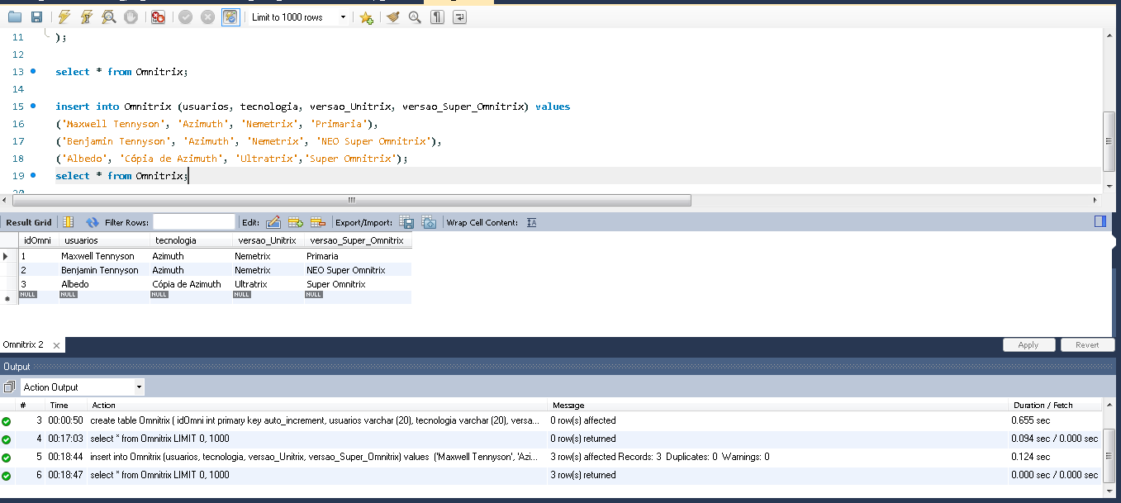

**-------------------------------------------------------------------------------------------------------------------**

*create table Alien (*

*idAlien int primary key auto_increment,*

*nomeAlien varchar (50),*

*especieAlien varchar (50),*

*caracteristica varchar (50),*

*caracteristica2 varchar (50),*

*qtd_aparicao int check (qtd_aparicao > 0 and qtd_aparicao < 100),*

*planetaNatal varchar (50),*

*fkOmnitrix int,*

*foreign key (fkOmnitrix) references Omnitrix (idOmni)*

*) auto_increment = 100;*

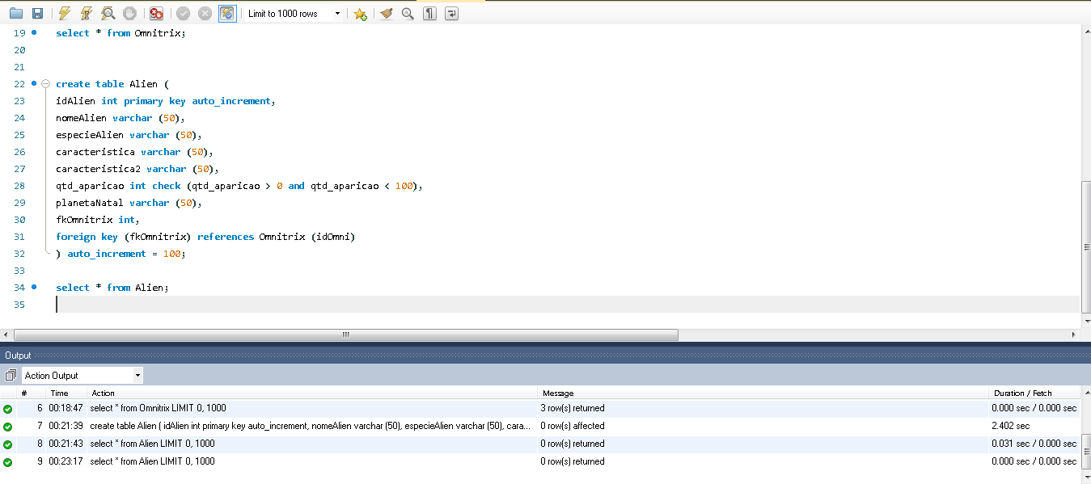

*Select * from Alien;*

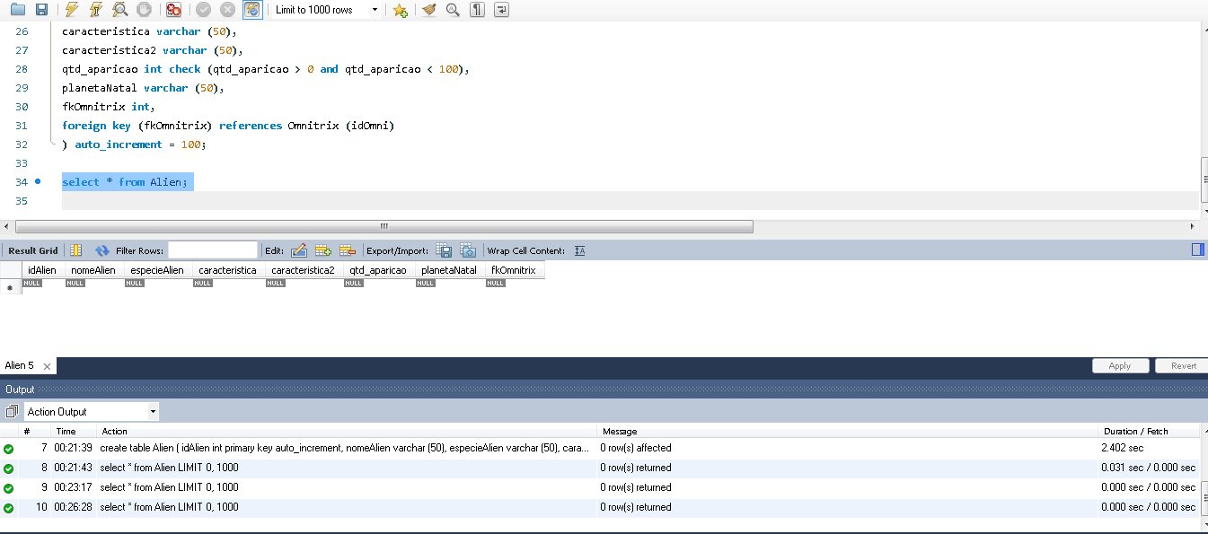

**-------------------------------------------------------------------------------------------------------------------**

*insert into Alien values*

*(null, 'Wrath', 'Appoplexiano', 'Tigre Humanoide', 'Agressividade Incontrolavel', 41, 'Appoplexia', 1),*

*(null, 'Ultra T', 'Mecamorfo Galvanico', 'Humanoide Tecnologico', 'Manipulador de Equipamentos', 25, 'Galvan B', 2),*

*(null, 'Chama', 'Pyronita', 'Humanoide Inflamavel', 'Usuário de Fogo Natural', 29, 'Pyros', 3);*

*select * from Alien;*

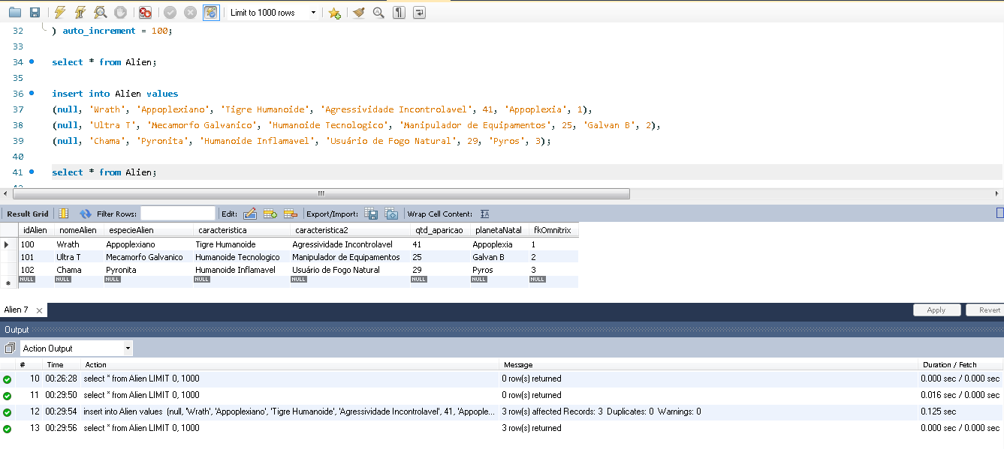

**-------------------------------------------------------------------------------------------------------------------**

*select * from Omnitrix;*

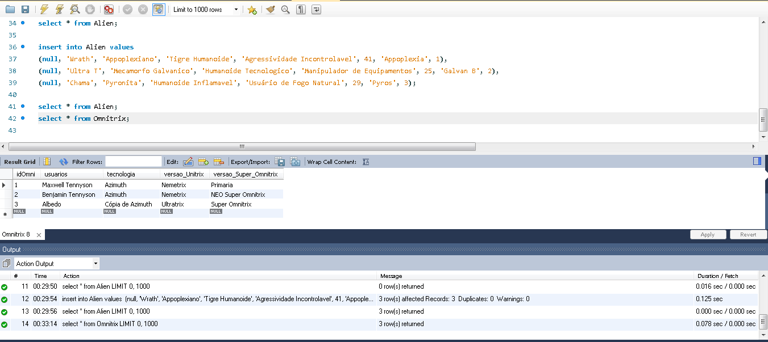

**-------------------------------------------------------------------------------------------------------------------**

*select * from Alien, Omnitrix where fkOmnitrix = idOmni;*

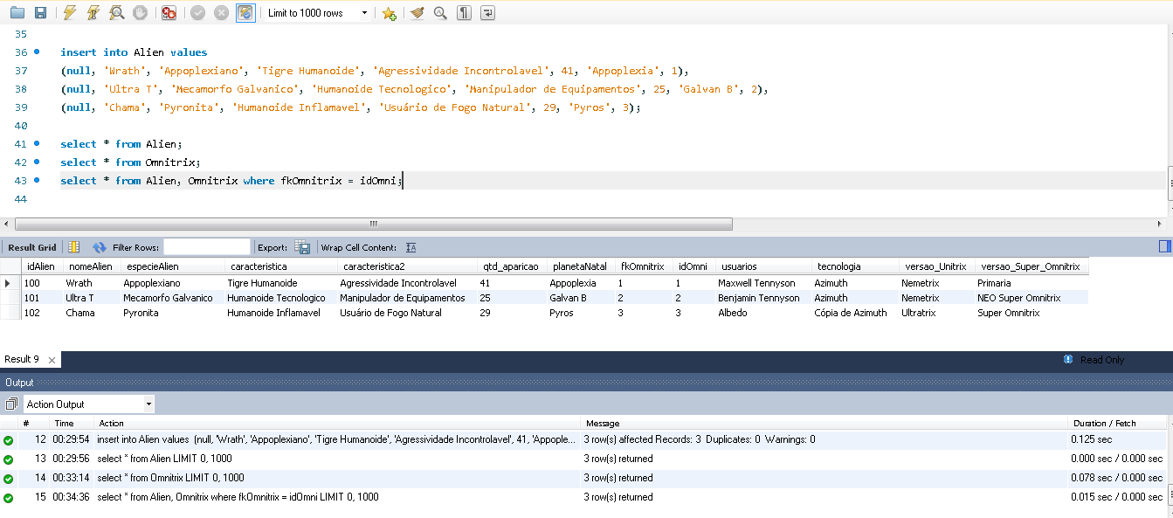

**-------------------------------------------------------------------------------------------------------------------**

*select * from Alien, Omnitrix where fkOmnitrix = idOmni and tecnologia = 'Azimuth';*

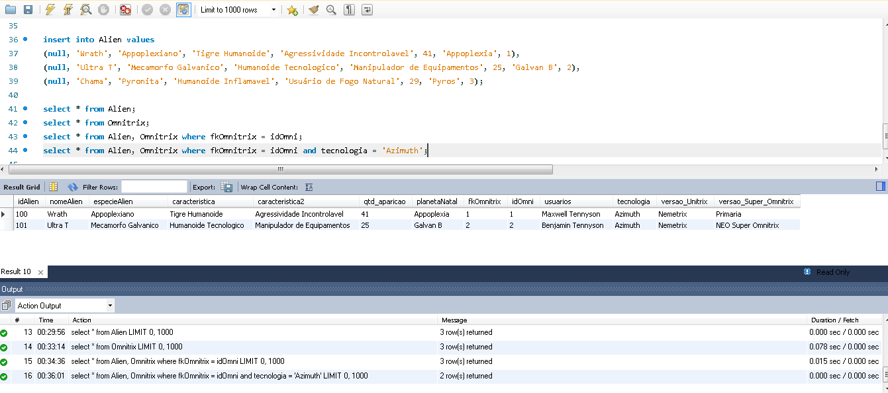

*select avg(qtd_aparicao) as 'Aparições no Desenho' from Alien;*

